

Sri Lanka Institute of Information Technology

**Institute Management System**

Design Document

Information Technology Project (IT2080)

2018

ITP-2018-MLB-G1-12

Submitted by:

1. IT16067684– Ramanayaka R.A.M.M.P
2. IT16063556– Vijeyanga M.S.O.V
3. IT16065154– Maduranga G.D
4. IT17128278– I.C.S. Ileperuma
5. IT17124690– Wijesekara W.A.M.P

Submitted to:

…………………………..

(Supervisor’s signature)

**1. Introduction**

Kings Academy is an EFL (English as a Foreign Language) Institute which offers various courses dedicated to quality English. It is a registered institute by Sri Lankan government which was established on 2015. The academy is equipped with all relevant amenities including sophisticated lecture halls, study areas and a small library, and approximately three hundred current students, more or less. With a good reputation among people and the frequent growth, a computerized system seemed essential for Kings Academy to maintain their activities, which led to the inauguration of this project.

The academy is located in the center of the Ratnapura city and currently one of the well-known and most recommended institutes for students looking for English courses dedicated to IELTS. It also offers long time programs for students following Ordinary Level and Advanced Level examinations, as well as short time courses for Adults and Employees to improve their existing knowledge in a short period of time.

The system required by the Kings Academy mostly concerns on making several important functions to be performed quicker than the present way and it requires an effective way to keep records of all the related parties such as Students and Employees. This information is often used with the payment processes and students progress evaluations. For instance, a full report of each individual student (including attendance, exam marks etc) is given to the student at the end of each course. Also, the system should help the management in every possible aspect when it comes to adding and removing new users, attendence marking, employee salary calculations, assiging lecture halls etc.

The system should also provide a solid platform for students and teachers to interact with each other. Students should be able to post their own questions into a Q&A section where teachers can help them by answering these questions. Teachers can also publish new articles and provide course materials via the system. This platform acts like a mini social network where students and teachers are connected for educational purposes.

Kings Academy also has a small library where students can borrow physical copies of books under certain terms and conditions. This information should also be tracked by the system, and notify the System Admin when students are misusing the library against the terms.

As a startup company, Kings Academy does not have any website at the moment. They need the front page of the web application to be a static web page where unauthorized users can grab information like contact numbers and latest courses.

**Login**

* Users have to log into the system before proceeding.

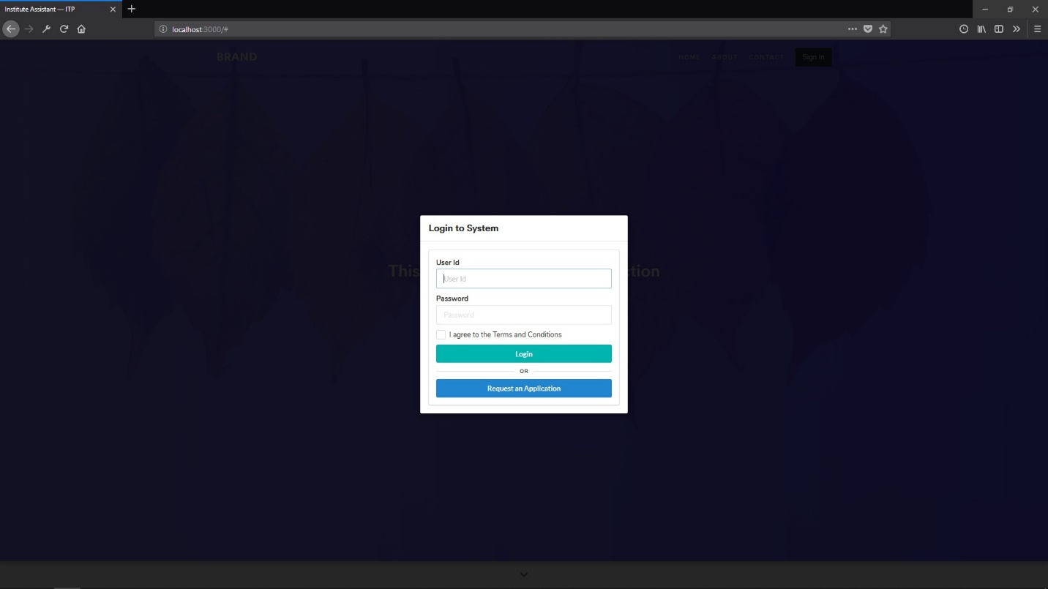

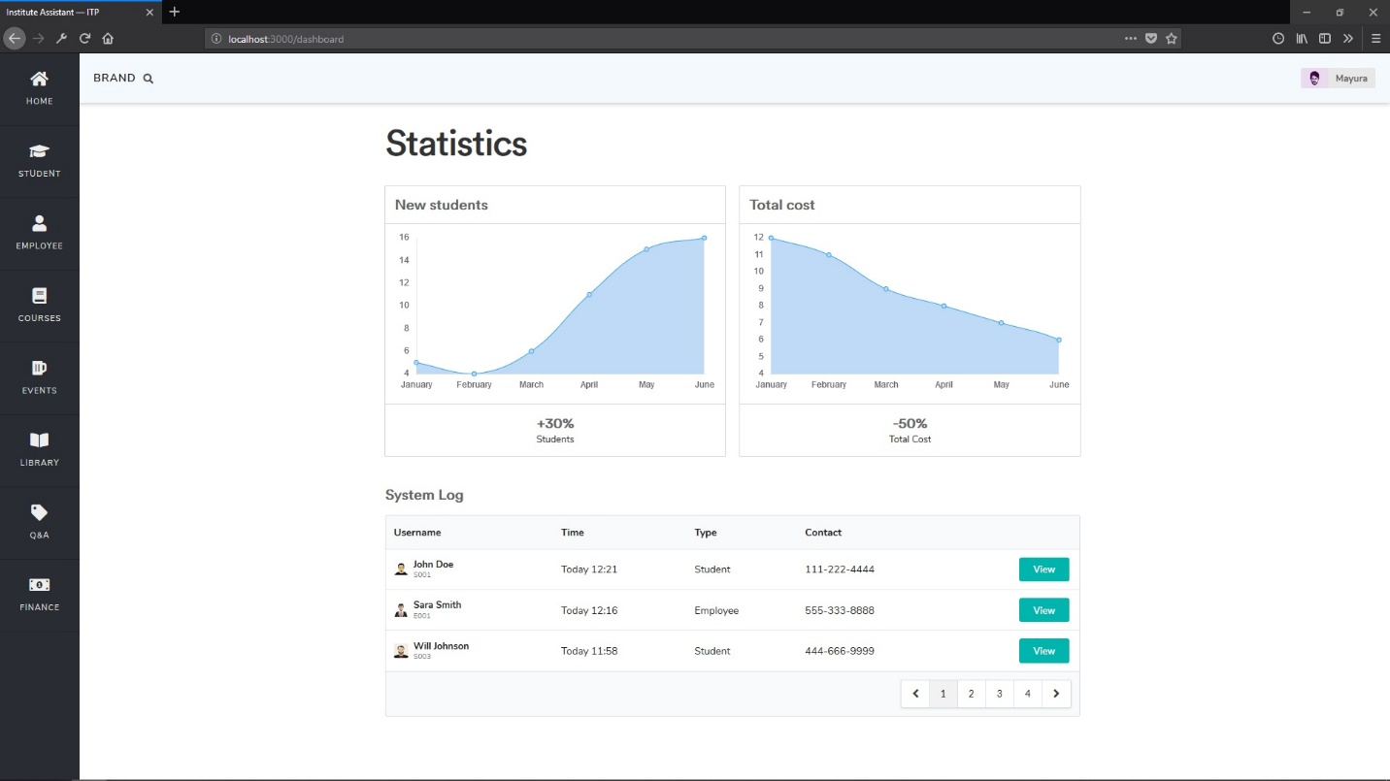

This page will display an overview of the entire system.

**Employee Management**

* Main page for employee management

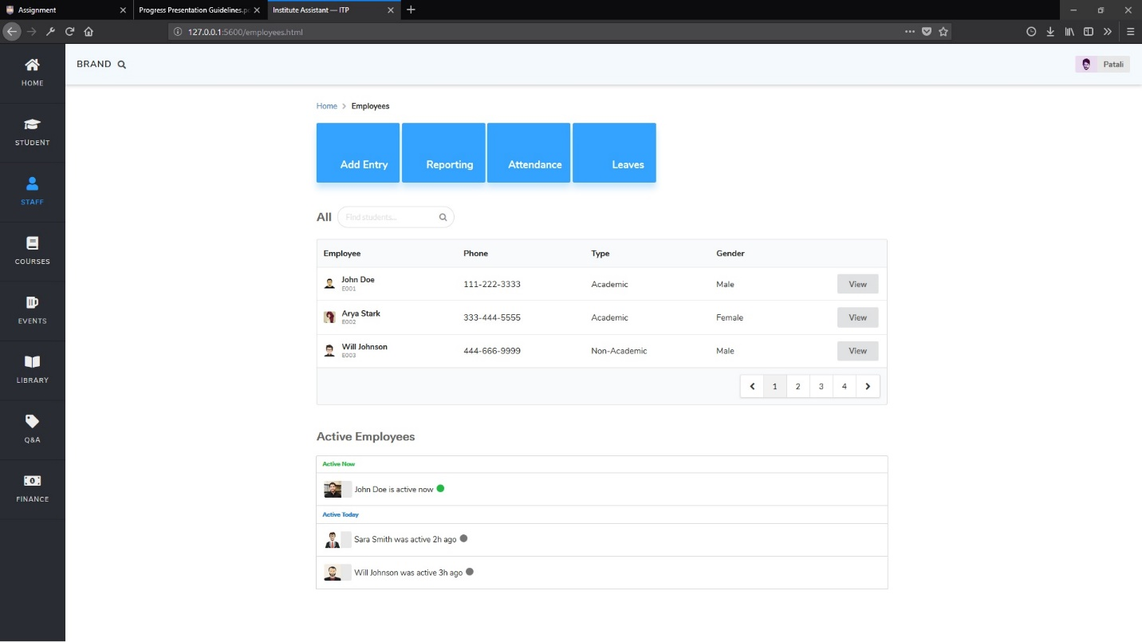

* Add/Edit employee form.

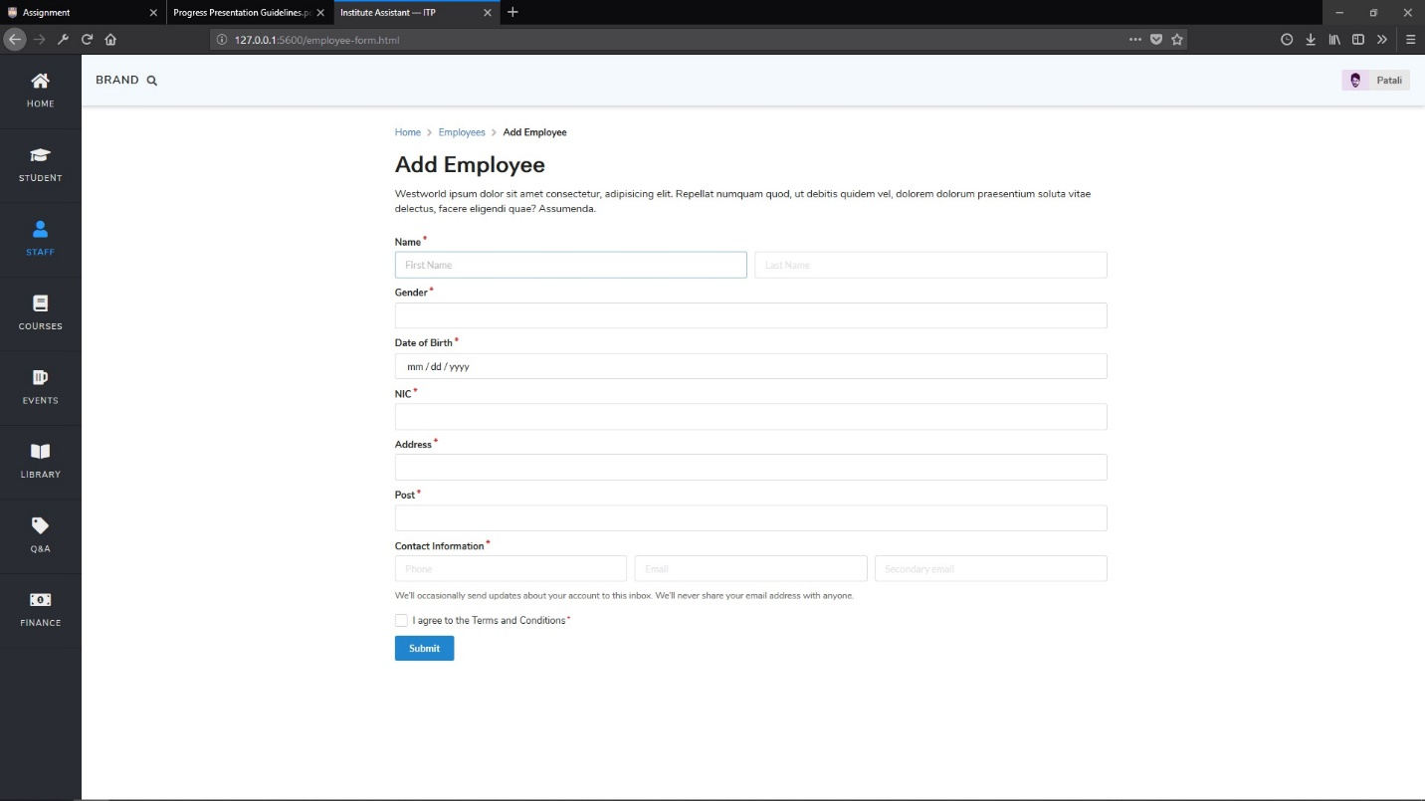

**Student Management**

* Main page for student management

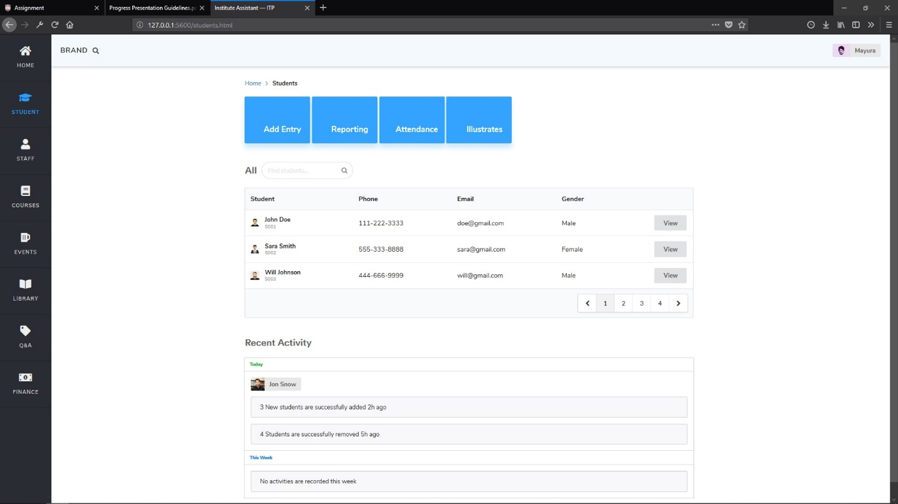

* Add/Edit student form

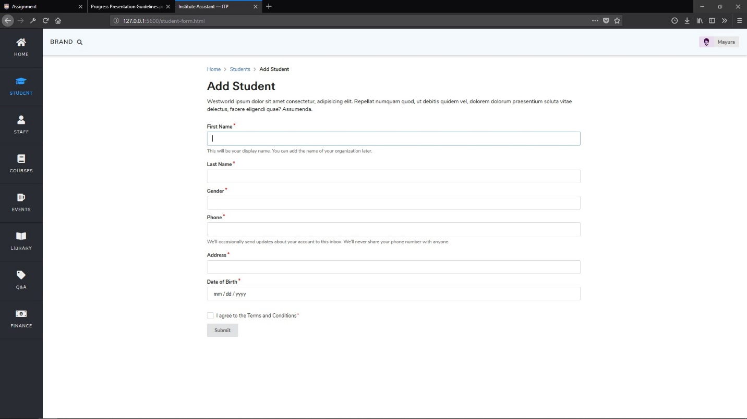

**User Profile**

Both employees and students are considered application users with almost similar attributes. The same markup for user profile is shared across all the users within the system.

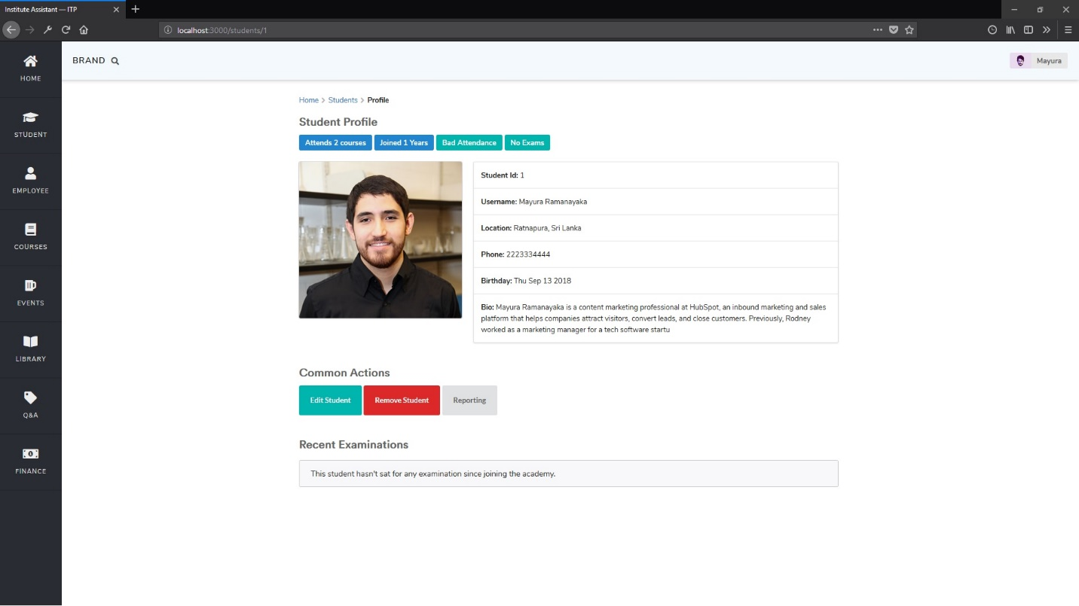

* Common Actions: Edit / Delete / Report Generation

**Q&A**

Q&A is section within the application where students and teachers can interact with each others. Following is a screenshot of the prototype that has one question and one answer.

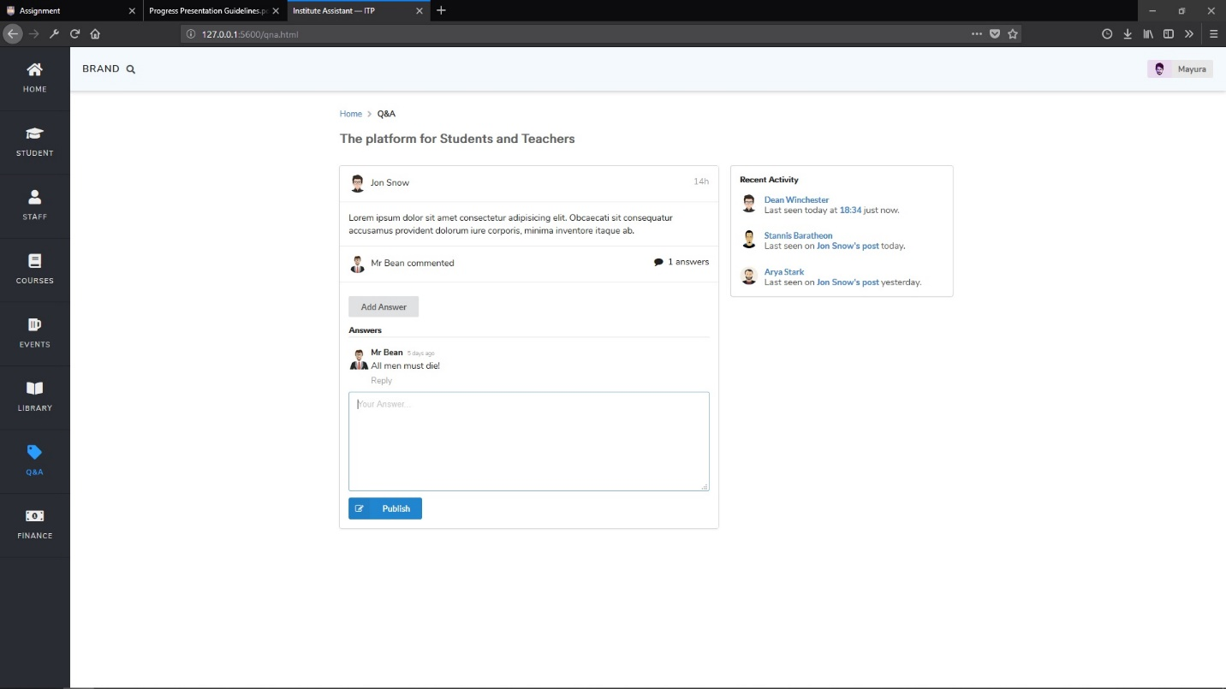

**Attendence Marking**

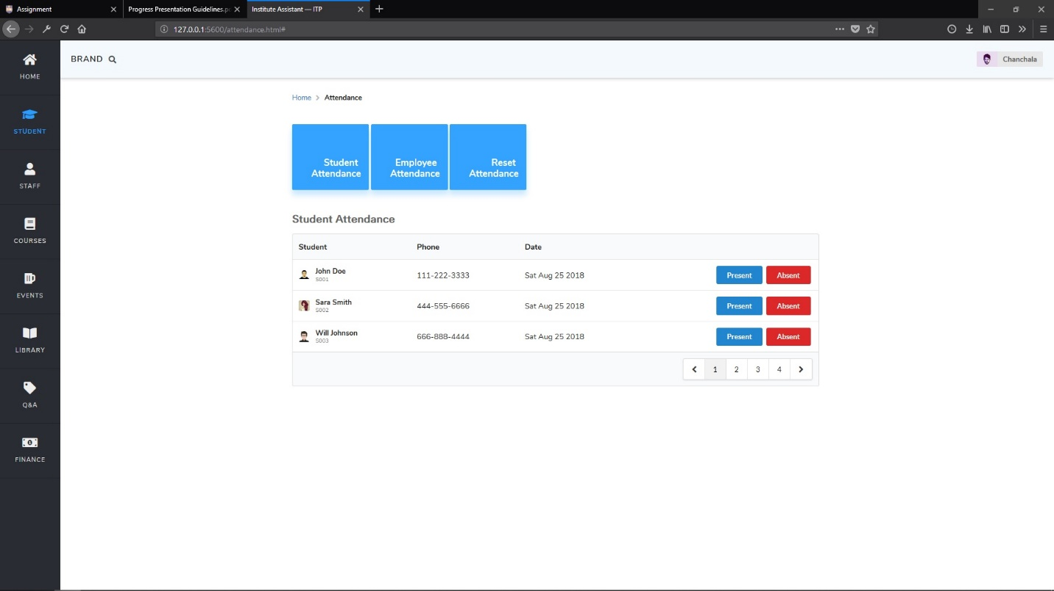

* Data will be dynamically loaded depending on the button (Student Attendance or Employee Attendance) that was clicked.
* This UI can be considered as a simple client that uses the Attendance Recording API. The API is specially developed to communicate via json, so that other client apps can (such as a desktop or mobile app) also use the same codebase.

**Events Management**

* Main page for Events

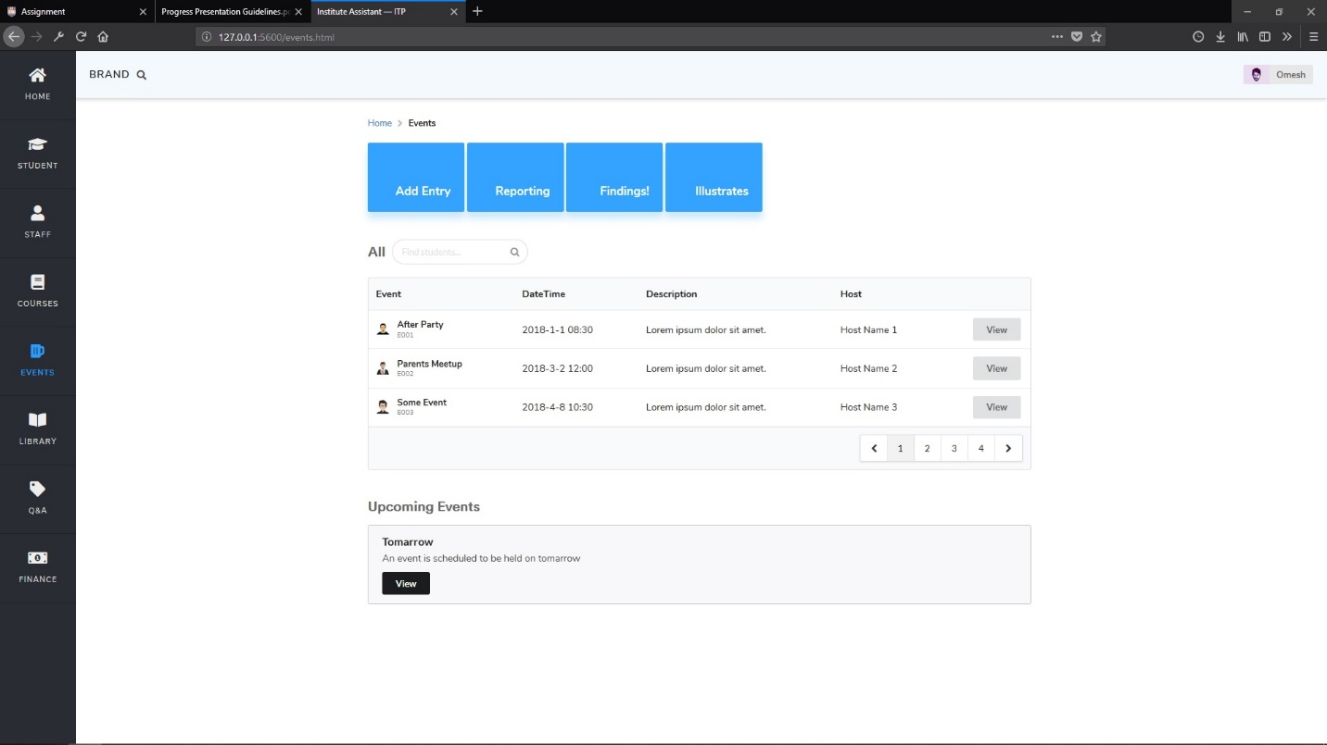

* Add/Edit event page

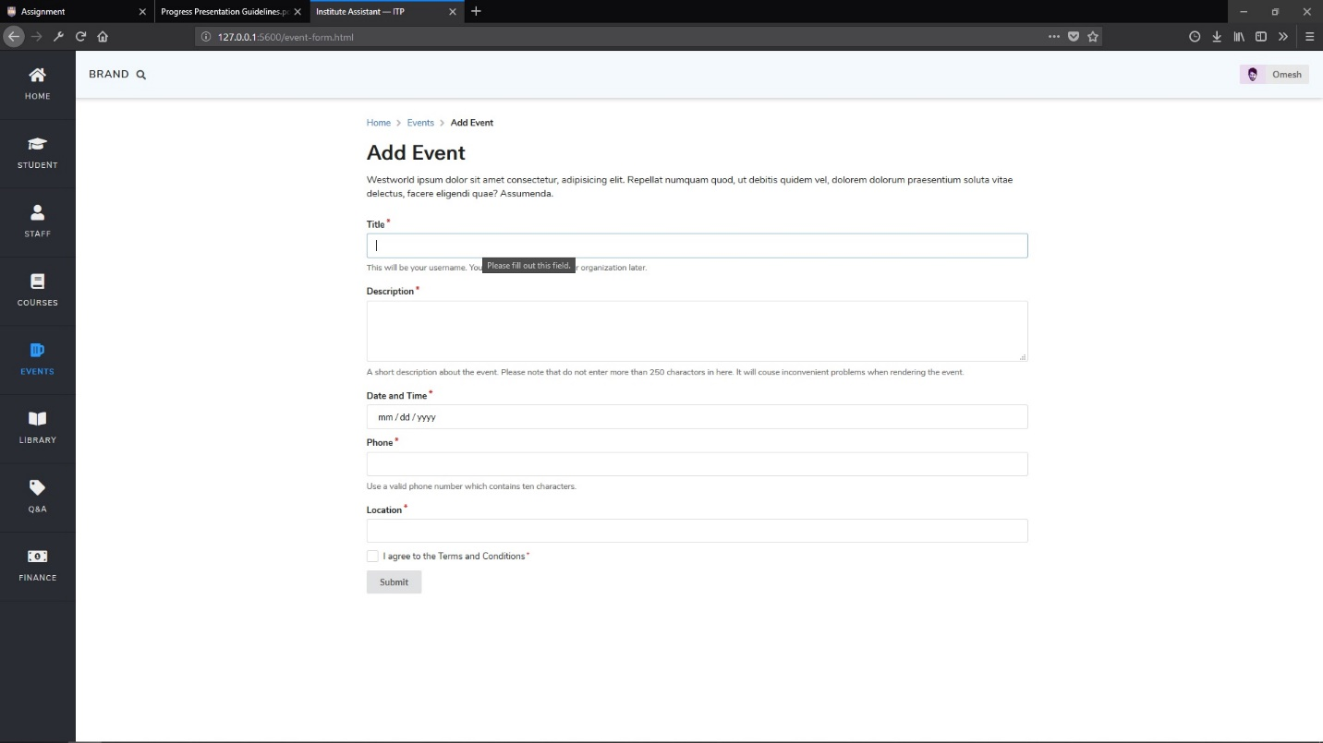

We’ll add seperate page that displays events in nice way for Students and other unauthorized parties.

**Library Management**

* Main page for Library management.

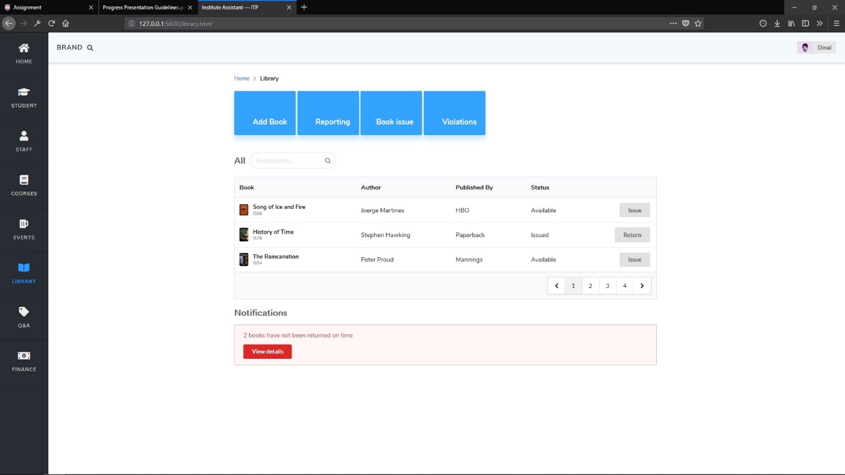

A book can be returned or issued by clicking on Issue or Return buttons.

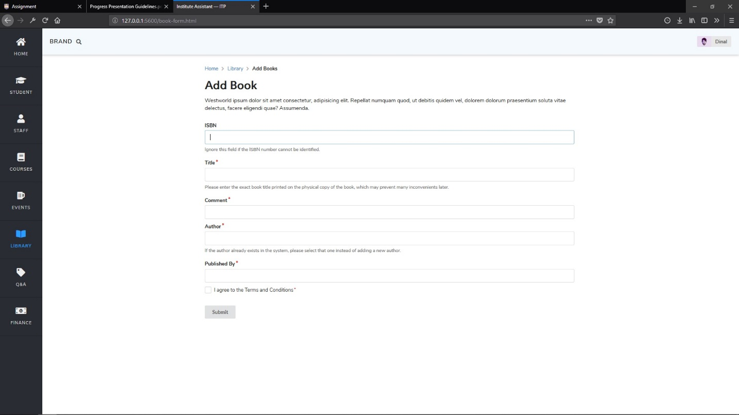

**Class diagram**

